Purpose
The purpose of the CANable is to be able to communicate between the JETSON and the motor controllers of the drive wheels using CANbus communication protocol. This off-the-shelf board facilitates this communication. (idk I wrote this fast)

TODO (To delete once done):
- Write the python code using python-can to receive and transmit

CANable Model: MKS CANable V2.0
Important Links:
Github: https://github.com/makerbase-mks/CANable-MKS/tree/main
CANable Website: https://canable.io/
Python-can library documentation: https://python-can.readthedocs.io/en/stable/bus.html#transmitting
Cangaroo software (not mandatory, used to see send and receive messages): https://canable.io/getting-started.html#cangaroo

CANable Firmware Update:
Follow the following link to be able to update the board.
https://www.youtube.com/watch?v=6MChPbeG6D0&ab_channel=MakerbaseTeam
Note 1: You can choose to update on the website or by downloading a software. The former is preferred because of its simplicity.
Note 2: Contrary to the video, please select “slcan” instead of “candlelight”. It was chosen because of its compatibility with Windows. Linux works well with “candlelight” but if the user decides to use this instead, the code needs to be modified accordingly.
Note 3: Before updating the firmware, please first move the jumper on the board from 120R to BOOT. Switch back to 120R when you are done. (120R is for the termination resistor value which allows for CAN communication.)

Set Up:
- Hardware setup:
  - Connect the CAN RX/TX pin of the STM32 with the corresponding pins on the CAN transceiver (make sure the transceiver has 120 Ohms termination resistance in parallel in between its CANH and CANL terminal). See the Annex at the very end of this document for finding the right pins on the STM.
  - Connect CANH/L to the corresponding pins on the CANable.
  - Connect the GND and VCC of the transceiver to the GND and 5V of the STM32 (do not connect to 3.3V since the transceiver is made for 5V). See the Annex at the very end of this document for finding the right pins on the STM.
  - Connect the CANable’s GND with the STM32 GND.
- Run the Python code.
  - If it is not properly working, you can use cangaroo to see if the CAN messages are sending/being received at all.
    - If using STM32 to communicate with the CANable, see Testing the communication with Cangaroo and STM32.

Testing the communication with Cangaroo and STM32:
- Download Cangaroo (see CANable website for more details):
  - https://canable.io/getting-started.html#cangaroo
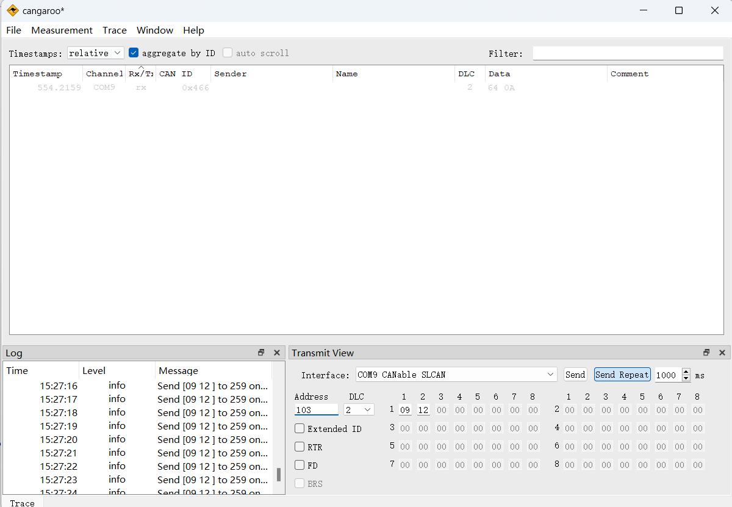
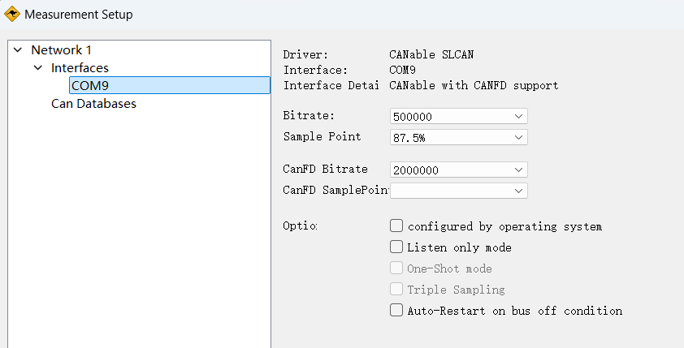
- In order to receive messages from the STM32, set the bitrate as above (we are using the standard CAN protocol so the CANFD bitrate can be ignored). You can access it under Measurement > Setup.
- To send messages, note down the ID that the STM32 accepts (it can be found in main.c). The DLC is the length of the message, make sure it matches the length accepted by the STM32, found under .
- Finally, Start Measurement to receive CAN messages and press Send Repeat to send CAN messages.

Python Code Explanation

CAN explanation:
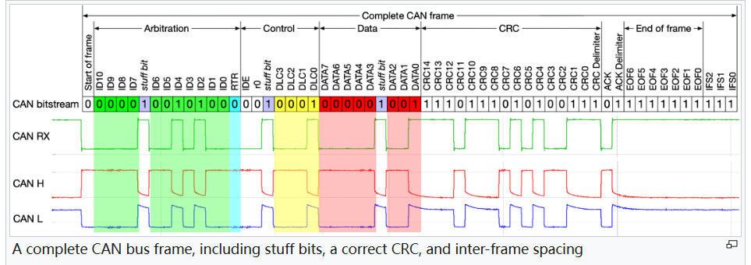
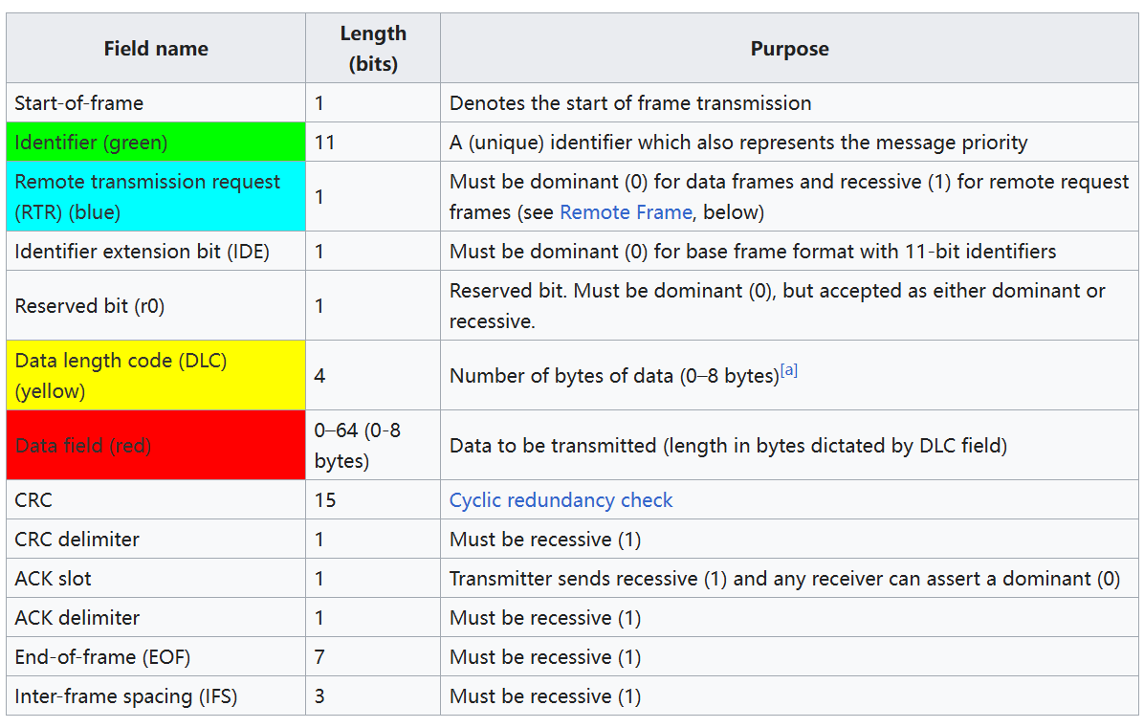

Annex:

How to connect the CANable with an STM32-F446RE
3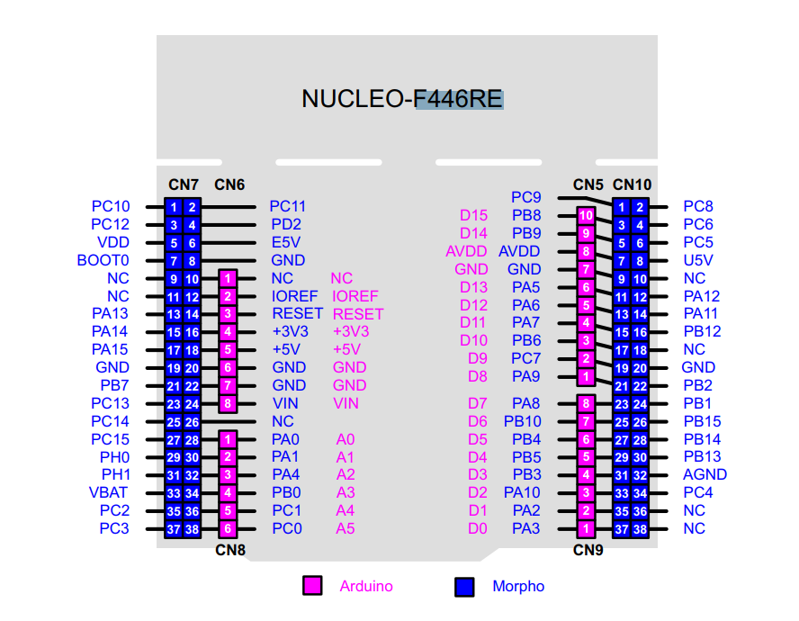
From the STMIDE’s .ioc file, we observe that
- PA11 –> CAN_RX
- PA12 –> CAN_TX
The above image shows which physical pin to connect to when using the nucleo-f446RE board.

